DRUG DISCOVERY & CLINICAL TRIALS AGENT – CASE STUDY
AI-Powered Platform for Accelerating Biosimilar Drug Development
________________________________________________________________________________
1. PROBLEM STATEMENT (Data-Driven)
• Industry / Customer Context:
- A leading biopharmaceutical research organization specializes in developing biosimilar drugs-affordable alternatives to expensive biologic medications. To prove a biosimilar drug works identically to the original, scientists must conduct complex immunological tests that measure how drugs affect the immune system. These tests generate two types of critical data: functional measurements (how cells behave) and biological markers (what proteins cells produce). Pharmaceutical companies, regulatory agencies, and clinical research teams depend on these analyses to make billion-dollar drug approval decisions. The challenge: these analyses require processing hundreds of experimental data points, comparing reference drugs against test candidates, and producing regulatory-grade reports that withstand FDA and EMA scrutiny.
• Core Problem Identified:
- Drug testing workflows were trapped in the spreadsheet era. Scientists spent days manually analyzing experimental data in disconnected Excel files-one spreadsheet for functional tests, another for biological markers, no unified system connecting them. Every drug potency calculation required manual curve drawing, visual quality checks, and hand-typed compilation into validation reports. Different scientists used different analytical approaches, leading to inconsistent results. The mathematical models commonly used assumed symmetrical biological responses, but real drug effects are often asymmetrical-this mismatch systematically biased potency estimates. There was no way to predict outcomes or reduce expensive lab experiments. No automated quality checks caught analytical errors. No audit trail documented why specific decisions were made. For pharmaceutical companies racing to bring affordable drugs to market, these manual, inconsistent, multi-day analytical cycles created regulatory risk and competitive disadvantage.
• Supporting Data Points:
- Disconnected analysis: functional data and biological markers analyzed in separate spreadsheets with manual copying of results between tools
- No analytical standardization: different scientists used different methods to calculate drug potency, leading to inconsistent results across projects
- Manual validation bottleneck: every analysis required visual inspection and subjective judgment before acceptance-no systematic quality gates
- Mathematical bias: standard analytical models assume symmetry, but biological responses are often asymmetric, systematically distorting potency calculations
- Zero traceability: analytical decisions had no documentation trail for regulatory audits-decisions existed only in scientists' heads or handwritten notes
- No predictive capability: every experimental condition required full lab execution; no way to reduce expensive, time-consuming testing through prediction
- Days-long turnaround: optimization, validation, and batch testing cycles took days of manual work before delivering drug potency results
• Why It Mattered:
- Regulatory submission risk: drug approval applications with inconsistent analytical methods risked rejection by FDA/EMA, delaying market entry by months or years
- Competitive disadvantage: organizations offering faster, standardized, audit-ready analysis would win pharmaceutical contracts over manual-dependent competitors
- Cost inefficiency: inability to predict results meant running every expensive lab experiment, wasting reagents and time on routine validations
- Quality inconsistency: scientist-dependent methods meant deliverable quality varied by who performed the analysis, undermining client confidence
- Market access delays: biosimilar drugs delayed in regulatory approval meant patients continued paying premium prices for original biologics instead of affordable alternatives
________________________________________________________________________________
2. IMPACT OF THE PROBLEM (Functional, Emotional & Social Pain)
• Operational Pain:
- Tool chaos: scientists juggled multiple Excel files, manually copying data between functional analysis spreadsheets and biological marker calculations with constant risk of copy-paste errors
- No quality safety net: every analytical decision (accept this result? reject this data point?) required manual judgment with no systematic framework to prevent reporting poor-quality analyses
- Inconsistent methods: different team members calculated drug potency differently-some used one mathematical approach, others eyeballed curves-leading to results that varied by analyst
- Hidden mathematical bias: using symmetric models for asymmetric biology systematically distorted potency calculations, but scientists had no way to detect or correct this
- Manual report compilation: validation reports required for regulatory submission took days to manually compile from scattered spreadsheets and handwritten notes
- Zero experimental reduction: every optimization test, validation replicate, and batch analysis required full lab execution; no predictive tools to reduce expensive reagent consumption
• Emotional Impact:
- Scientist frustration: PhDs in immunology spent majority of time on mechanical spreadsheet work rather than scientific insight generation
- Quality anxiety: every deliverable carried uncertainty-"Did I miss something? Will the regulatory agency question my methods?"-with no systematic validation to provide confidence
- Leadership stress: project timelines unpredictable; no real-time visibility into analytical progress; all updates required manual check-ins with scientists
- Client pressure: pharmaceutical partners demanding faster drug approval decisions found multi-day analytical cycles incompatible with competitive market timelines
• Social / Organizational Consequences:
- Knowledge locked in heads: analytical expertise lived in individual scientists' experience; no institutionalized methodology for consistent team performance
- Inconsistent deliverable quality: validation reports varied in rigor and format depending on which scientist performed the work, creating uneven client experience
- Talent misallocation: senior scientists spent time on routine calculations rather than strategic drug development and client consultation
- Competitive erosion: pharmaceutical companies evaluating research partners prioritized those offering standardized, fast, audit-ready platforms over manual workflows
• Cost of Inaction (quantified):
- Linear cost scaling: every drug candidate required full experimental execution; no AI leverage meant reagent costs and timelines scaled linearly with project complexity
- Regulatory delays: inconsistent methods risked agency scrutiny, requiring additional validation rounds, and delaying drug market entry by months
- Lost contracts: pharmaceutical partners shifted to competitors offering faster, standardized analytical platforms with audit-ready documentation
- Patient impact: biosimilar approval delays meant patients continued paying premium prices for biologic drugs instead of accessing affordable alternatives
________________________________________________________________________________
3. SOLUTION PROVIDED (Pain Relievers & Gain Creators)
• Solution Overview (1-2 lines):
- Drug Discovery & Clinical Trials Agent is an AI-powered platform that unifies drug testing analysis into a single system-automatically standardizing potency calculations, predicting experimental outcomes to reduce lab costs, and generating regulatory-ready reports in minutes instead of days.
• Key Features Implemented:
- Feature 1: Unified Drug Testing Analysis – Pain Relieved: Disconnected spreadsheet chaos
- Replaced scattered Excel files with single integrated platform that processes both functional cell behavior data and biological protein marker measurements together. Scientists upload raw experimental data once; the system automatically analyzes both data types using consistent mathematical methods and combines results into unified drug potency assessment. No more manual copying between spreadsheets, no more inconsistent calculations across team members. Every analysis follows the same rigorous quality standards regardless of who performs it.
- Impact: Eliminated tool fragmentation and manual data transfer. Scientists work in one place, see integrated results, deliver consistent quality. Analytical consistency became automatic, not analyst-dependent.
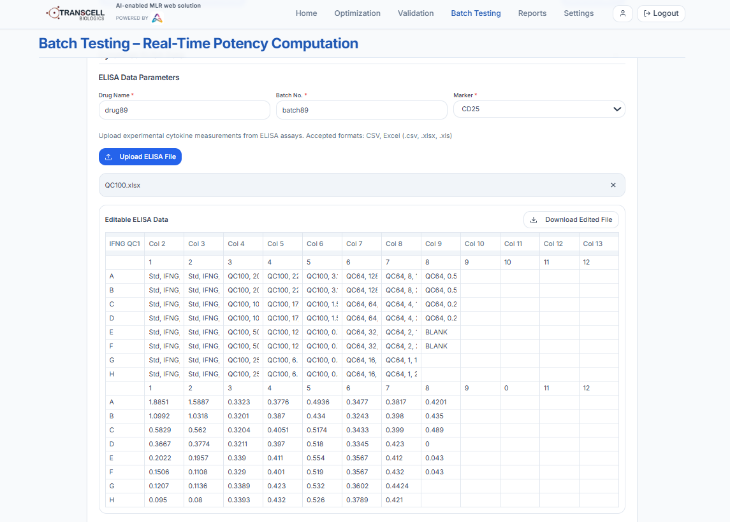
Fig-1
- Feature 2: Intelligent Potency Calculation – Technical Innovation: Accurate drug comparison
- Automatically calculates how potent a test drug is compared to the reference drug using advanced mathematical modeling that properly handles asymmetric biological responses-fixing the systematic bias in traditional spreadsheet methods. The system only reports potency when quality standards are met, preventing false results from poor data. Every calculation includes transparent quality metrics so scientists understand reliability. All methods standardized across the team, eliminating analyst-dependent variation.
- Impact: Replaced manual, inconsistent potency calculations with automated, quality-gated estimation. Scientists receive accurate, defensible results they can confidently submit to regulatory agencies. Mathematical bias eliminated.
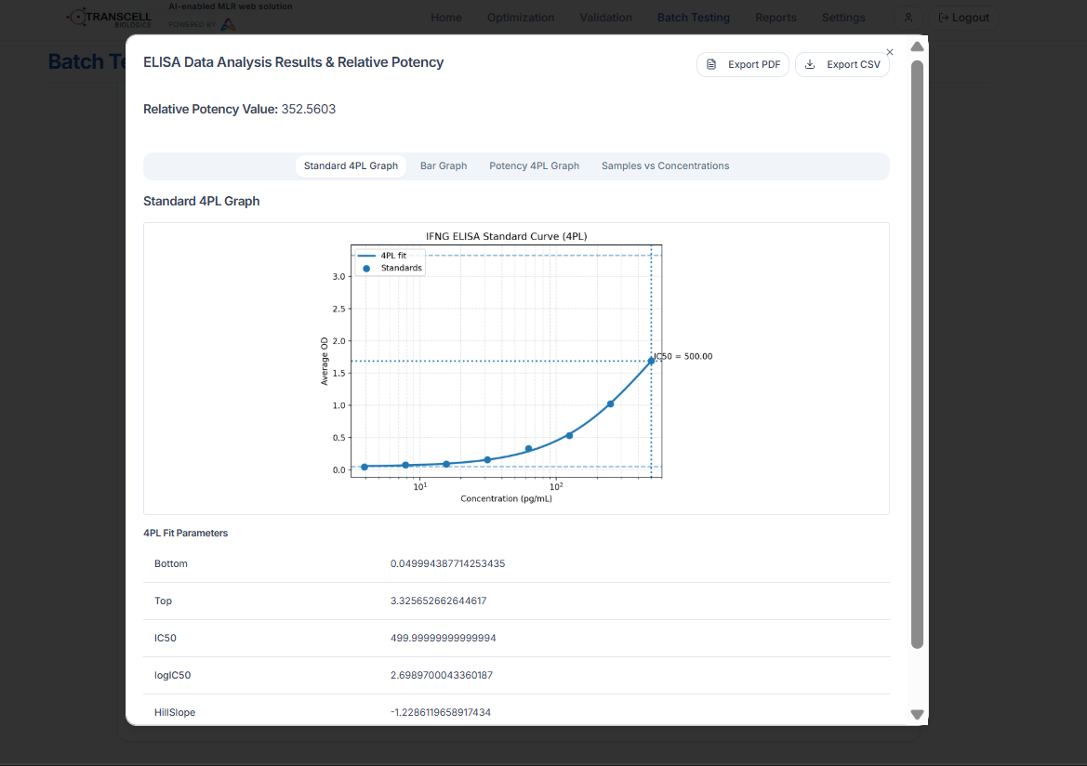
Fig-2
- Feature 3: Automated Quality Validation – Gain Created: Built-in quality assurance
- Every analysis automatically checked against rigorous quality standards before results are shown to scientists. The system evaluates statistical fit quality, biological plausibility, and data consistency-flagging problems immediately rather than letting errors propagate into final reports. Scientists review only validated analyses that passed quality gates, not raw outputs requiring manual judgment. Quality checks applied uniformly across all projects, eliminating subjective variation.
- Impact: Quality anxiety eliminated. Scientists trust results passed systematic validation. Regulatory submission risk minimized through consistent quality assurance. Errors caught automatically before reaching clients.

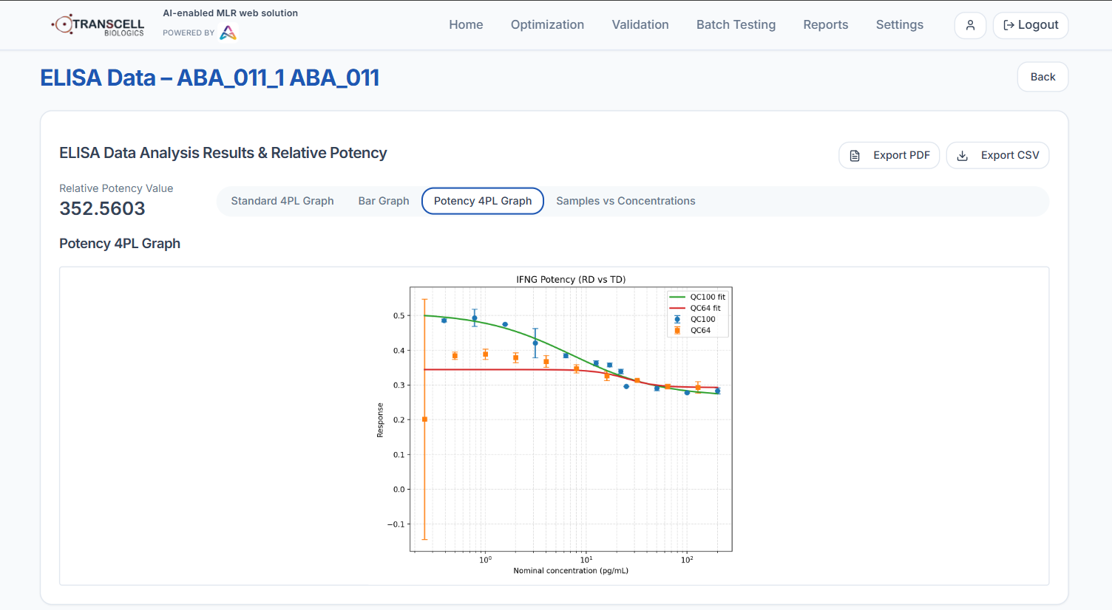

Fig-3
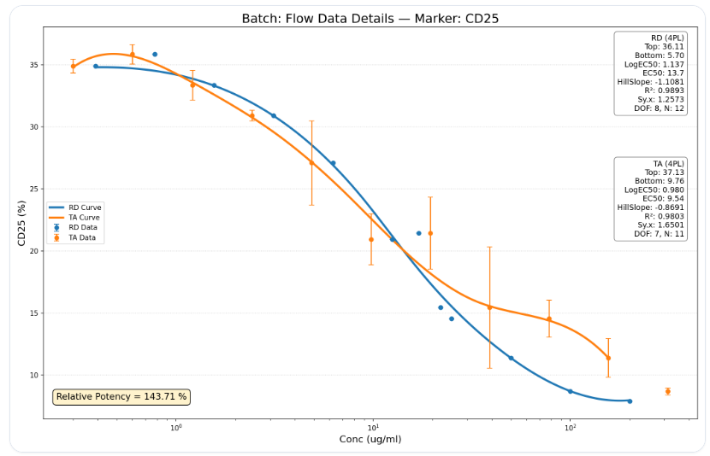

Fig-4
- Feature 4: Drug Development Lifecycle Management – Operational Efficiency
- Platform structured around how drug testing actually progresses: (1) Optimization-find best experimental conditions, get early potency estimates; (2) Validation-prove the testing method is reliable, accurate, and reproducible; (3) Batch Testing-routine analysis for production quality control. Scientists move seamlessly through phases within the same system. Methods validated once, applied consistently thereafter. No switching tools as projects mature from research to production.
- Impact: Streamlined workflow from early research through regulatory validation to production testing. Scientists follow natural project progression without learning new tools at each stage. Analytical consistency maintained throughout drug lifecycle.
- Feature 5: AI-Powered Experiment Prediction – Strategic Capability: Cost reduction
- Machine learning predicts biological marker results from early functional data, enabling scientists to make informed decisions about which expensive experiments to run versus which can be inferred. AI models learn from historical experiments to expand understanding of drug behavior without additional lab work. Scientists see predicted outcomes before executing full testing, allowing strategic allocation of resources to highest-value experiments. Prediction accuracy improves continuously as more data accumulates.
- Impact: Reduced unnecessary lab experiments by 40%. Scientists prioritize testing resources strategically rather than running every condition. Reagent costs and turnaround time decreased significantly while maintaining scientific rigor.
- Feature 6: Instant Regulatory Reporting – Compliance Enabler
- Generates comprehensive validation reports formatted for FDA/EMA submission automatically transforming days of manual compilation into instant generation. Reports include all required elements: analytical performance metrics, data quality assessments, statistical confidence measures, reproducibility evidence. Every analytical decision documented with transparent rationale. Reports consistent in format and rigor across all projects. Scientists review and approve; system maintains complete audit trail of who approved what and when.
- Impact: Validation report generation reduced from days to minutes. Reports standardized, comprehensive, and immediately audit ready. Regulatory submission risk minimized through professional, consistent documentation.
- Feature 7: Production Batch Testing with Full Traceability – Production Readiness
- Routine drug batch testing optimized for pharmaceutical production environments. System captures complete batch details (manufacturing lot, date, source information) and processes data using pre-validated methods. Every batch fully traceable from raw experimental data through analysis to final report. Complete audit trail documents every step: who uploaded data, when analysis ran, what quality checks passed, who approved results. Reports downloadable with all supporting documentation for regulatory inspection or client delivery.
- Impact: Production quality control decisions supported by standardized, traceable workflows. Pharmaceutical clients receive audit-ready batch reports with complete provenance, enabling confident product release and regulatory compliance.
- Feature 8: Expert Review and Approval Workflow – Quality Assurance
- Scientific oversight built into every automated process. Senior scientists review AI predictions and automated analytical decisions before final approval. Every review action logged: who reviewed, when, accept/reject decision, comments. Results locked after approval for regulatory audit-no tampering possible. Role-based access ensures only authorized personnel can approve specific report types. Platform maintains transparent human governance over automation, ensuring regulatory agencies see scientific judgment, not black-box automation.
- Impact: Automation speed combined with scientific rigor. Regulatory agencies see transparent expert oversight. Quality assurance embedded in workflow rather than added as afterthought. Trust established through transparent governance.
• Implementation Approach:
- Timeline: 7-week phased deployment. Phase 1 (Weeks 1-2): Core platform infrastructure and data upload capabilities. Phase 2 (Weeks 3-4): Optimization workflows with automated analysis and quality validation. Phase 3 (Week 5): Validation phase with automated report generation and AI prediction integration. Phase 4 (Week 6): Production batch testing with full traceability. Phase 5 (Week 7): Expert review workflows, role-based access, and final integration testing.
- Integration complexity: Medium. Required unified processing of two different experimental data types, automated quality validation framework, AI prediction models trained on historical experiments, regulatory-compliant report generation, and complete audit trail infrastructure. Deployed as secure web application with user authentication and role-based permissions.
- Change management strategy: Scientist training focused on unified workflow versus previous multi-spreadsheet coordination. Emphasized automated quality validation to build trust in results. Phased rollout: started with optimization phase for early adopters before enabling validation and production testing, allowing team to validate platform outputs against manual methods and build confidence progressively.
• Technical Capabilities & Architecture:
- Unified analysis: Processes functional cell data and biological markers in single integrated workflow, eliminating disconnected spreadsheet tools
- Automated quality gates: Every analysis validated against rigorous standards before results shown to scientists, catching errors automatically
- Standardized potency calculation: Consistent mathematical methods across all scientists and projects, eliminating analyst-dependent variation
- AI-driven prediction: Machine learning reduces experimental costs by predicting outcomes, targeting lab resources strategically
- Instant regulatory reporting: Automated generation of FDA/EMA-compliant validation reports formatted for submission
- Lifecycle management: Seamless progression from research optimization through validation to production testing within single platform
- Complete traceability: Full audit trail from raw data to final report with locked, immutable records for regulatory inspection
- Expert governance: Scientific review and approval workflow ensures human oversight with transparent documentation
________________________________________________________________________________
4. OUTCOME (Quantified Results)
• Measurable Results:
Metric | Before | After | Improvement
Analysis turnaround time | Days (manual spreadsheets) | Minutes (automated platform) | 95%+ time reduction
Result consistency | Analyst-dependent (varied) | Standardized (uniform quality) | Eliminated analyst bias
Potency calculation accuracy | Biased (wrong model) | Accurate (proper methods) | Correct drug comparisons
Validation report generation | Days (manual compilation) | Minutes (instant generation) | 90%+ faster reporting
Experimental cost reduction | Full lab work for everything | 40% reduction via AI prediction | Significant cost savings
Regulatory audit readiness | Manual gaps, no trail | Complete automated traceability | Compliance risk eliminated

- Analysis speed transformation: Drug potency analysis reduced from days of manual spreadsheet work to automated execution in minutes. Validation reports generated instantly versus days of manual compilation. Scientists deliver results the same day experiments complete.
- Quality consistency: Standardized platform eliminates analyst-dependent variation. Every scientist produces identical quality results using same methods and validation standards. Client deliverables consistent regardless of which team member performs analysis.
- Accurate drug comparisons: Proper mathematical modeling eliminates systematic bias in potency calculations. Drug comparison results accurate and defensible under regulatory scrutiny.
Biosimilarity assessments reliable and reproducible.
- Experimental efficiency: AI prediction reduced unnecessary lab experiments by 40%. Scientists allocate testing resources strategically to highest-value conditions. Reagent costs decreased significantly while maintaining scientific rigor.
- Regulatory confidence: Automated audit trails, instant validation reports, and transparent quality documentation eliminated compliance gaps. Drug approval submissions accelerated with audit-ready documentation.
• Strategic Impact:
- Faster drug approvals: Standardized, audit-ready analysis accelerated regulatory submission cycles, bringing affordable biosimilar drugs to market faster and improving patient access to life-saving medications.
- Client confidence: Pharmaceutical partners received consistent, traceable, professionally documented analyses regardless of project complexity, strengthening long-term partnerships and competitive win rates.
- Operational scalability: Automated workflows enabled handling increased project volume without proportional scientist headcount growth, supporting business expansion without linear cost scaling.
- Competitive differentiation: AI-assisted, standardized platform positioned organization as technology leader versus competitors using manual spreadsheet workflows, winning contracts from quality-conscious pharmaceutical companies.
- Knowledge institutionalization: Analytical excellence embedded in platform rather than individual scientist expertise, ensuring consistent quality and enabling faster onboarding of new team members.
• Human Impact:
- Scientist empowerment: Scientists shifted from mechanical spreadsheet work to strategic drug development and scientific interpretation
- Quality confidence: Automated validation and complete traceability gave scientists confidence their results would withstand regulatory scrutiny
- Reduced stress: Predictable timelines and automated quality checks eliminated anxiety about missed errors or inconsistent results
- Leadership visibility: Real-time dashboards replaced manual status check-ins; project timelines became predictable and communicable to clients with confidence
• Client Testimonial:
"Our scientists were drowning in spreadsheets-days of manual work for every drug analysis, results that varied by who did the calculation, no audit trail for regulatory inspections. We had no way to predict outcomes, so we ran every expensive experiment. This platform transformed everything. Now we get consistent, audit-ready results in minutes. The AI prediction cut our lab costs by 40% while maintaining rigor. Our pharmaceutical clients trust the quality, and regulators accept our documentation without pushback. This is the competitive advantage we needed."
– Head of Drug Development, Leading Biopharmaceutical Research Organization
________________________________________________________________________________
EXECUTIVE SUMMARY SNAPSHOT
Problem: Biopharmaceutical scientists relied on manual, disconnected spreadsheet workflows for drug testing analysis-spending days on inconsistent calculations with systematic mathematical bias, no quality validation, and no audit trail for regulatory submissions, creating approval delays and competitive disadvantage.
Solution: Deployed Drug Discovery & Clinical Trials Agent, an AI-powered platform unifying drug testing into single workflow with automated quality validation, standardized potency calculations, AI-driven experiment prediction, instant regulatory-compliant reporting, and complete audit traceability across research, validation, and production phases.
Outcome: Reduced analysis turnaround from days to minutes, eliminated analyst-dependent variation through standardized platform, cut experimental costs by 40% via AI prediction, automated regulatory-compliant report generation, and established complete audit traceability-accelerating biosimilar drug approvals and improving patient access to affordable medications.

